**How to build a Loc camera with panning.**

Document created 3-6-2020

Rev A: 9-6-2020 – hardcoded WIFI credentials are replaced with log-on box.

Rev B: 19-6-2020 – code changes – and detailed setup and configurations for Blynk and ESP8266

Rev C: 21-11-2020 – code moved from this document to GitHub.

<https://github.com/JensKrogsgaard/cameraWaggon/blob/main/Cube_Camera_Pan_V4.ino>

By Jens Krogsgaard, [jenskrogsgaard@gmail.com](mailto:jenskrogsgaard@gmail.com), Syrenvaenget 10, 3520 Farum, Denmark - +4542669987

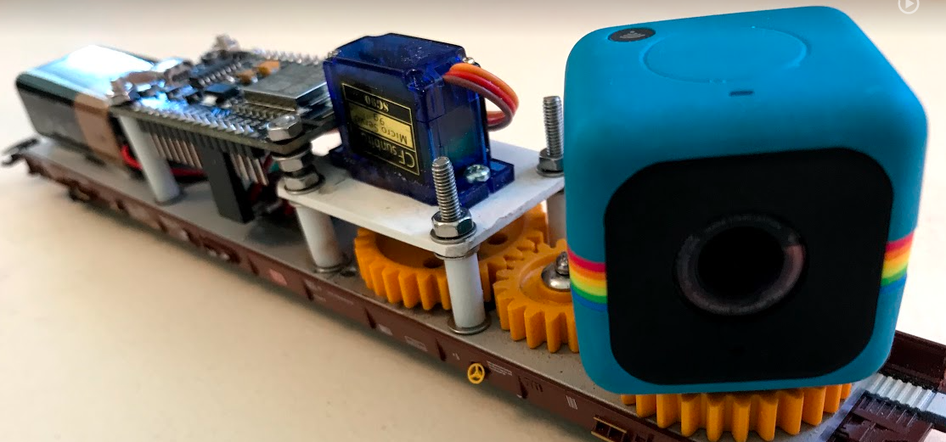

Content

1 Summary 2

1.1 Construction of the wagon 3

1.1.1 Bottom plate 3

1.1.2 Gear 3

1.1.3 Servomotor 4

1.1.4 ESP8266 – Node MCU 4

1.1.5 Power supply 5

1.1.6 Camera 5

1.1.7 Connect Node CMU with servo and battery 6

1.2 BLYNK – app 7

1.2.1 Import a copy of my Blynk app. 7

1.2.2 Make your own Blynk-app from scratch 12

1.3 Coding the Node MCU – ESP8266 15

# Summary

This document contains a description of how I designed and programmed a camera wagon. The camera can pan and it is controlled by an ESP9266 Node MCU. To operate the camera, I have made an a Blynk app.

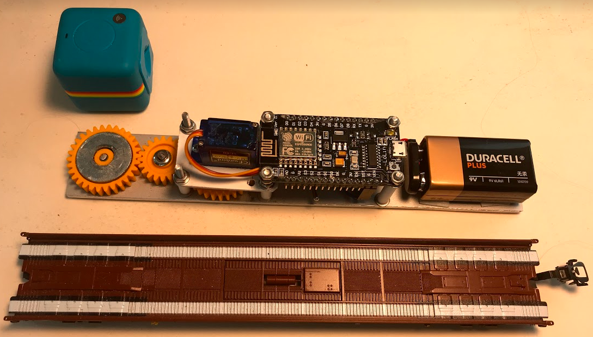

Check the YouTube video regarding this project: - click on the picture to start the video

[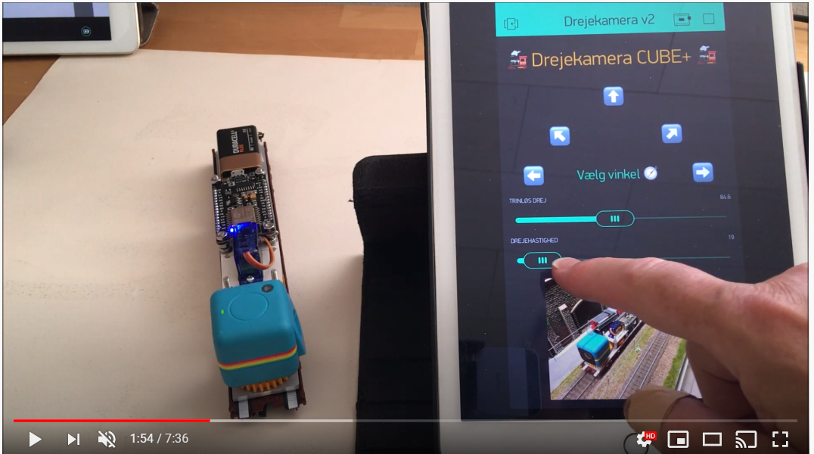](https://www.youtube.com/watch?v=6XWMY2tuYJo&t=29s)

## Construction of the wagon

### Bottom plate

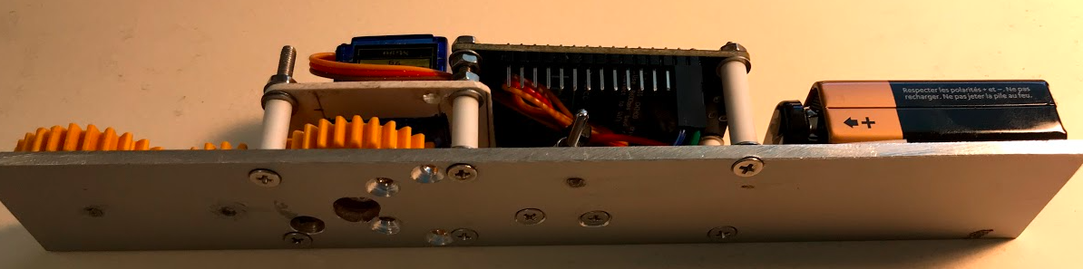

Metal plate – 31 x 200 x 3 mm. The weight of the plate stabilizes the wagon when driving

Bought in Bauhaus and cut out.

The bottom plate is designed to match the wagon from Rollende Landstraße / Rolling Road

### Gear

I have used 3 gear-wheels:

* wheel 31,5 mm
* 1 wheel 21,5 mm is used.

Bought at Conrad.de: <https://www.conrad.de/de/search.html?search=237663>

Shafts 4 mm – bought at bauhaus

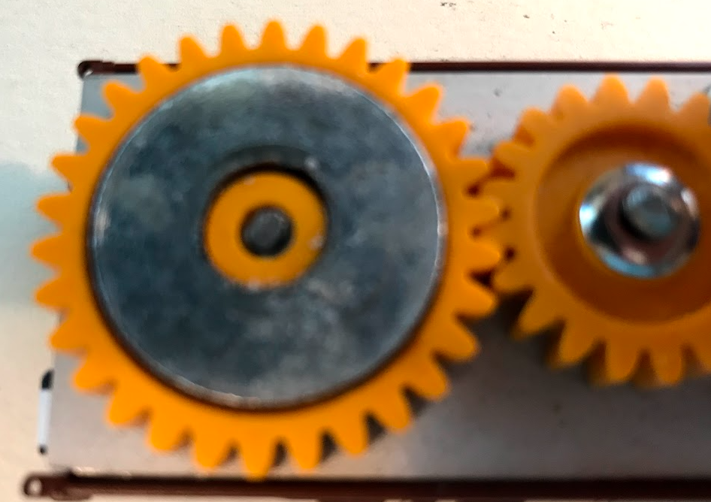

Glue a metal disc onto the gear-wheel to carry the camera - check that it is magnetic

### Servomotor

<https://www.elextra.dk/details/H34768/servomotor-mikro-3-72vdc-120ms-60-9g>

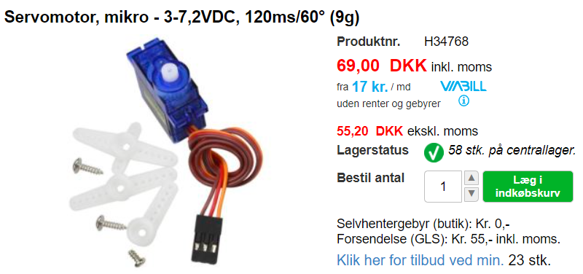

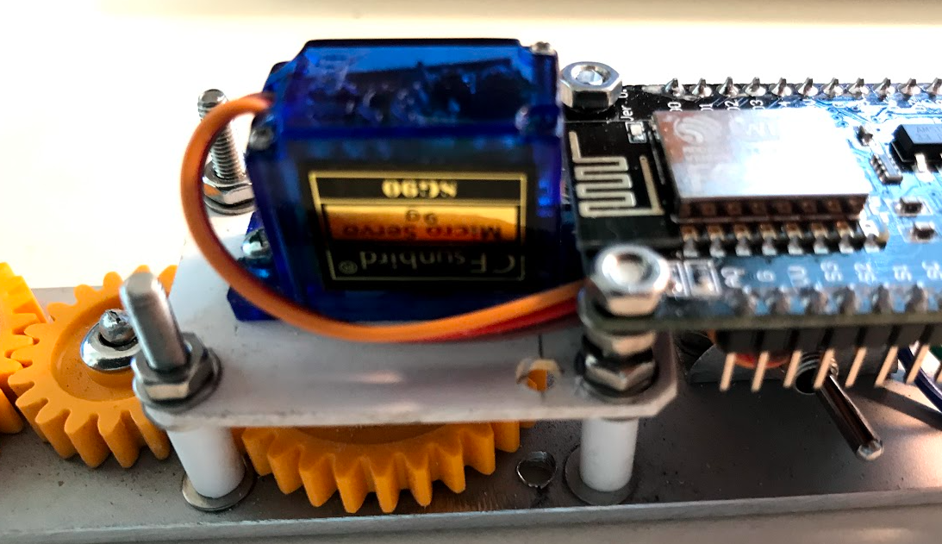

The servo is mounted on a 31 x 44 x 2 mm plastic plate

The screws are 3 mm - from the Bauhaus. The bushings are plastic tubes.

### ESP8266 – Node MCU

<https://www.conrad.de/de/p/joy-it-entwickler-platine-node-mcu-esp8266-wifi-1613301.html>

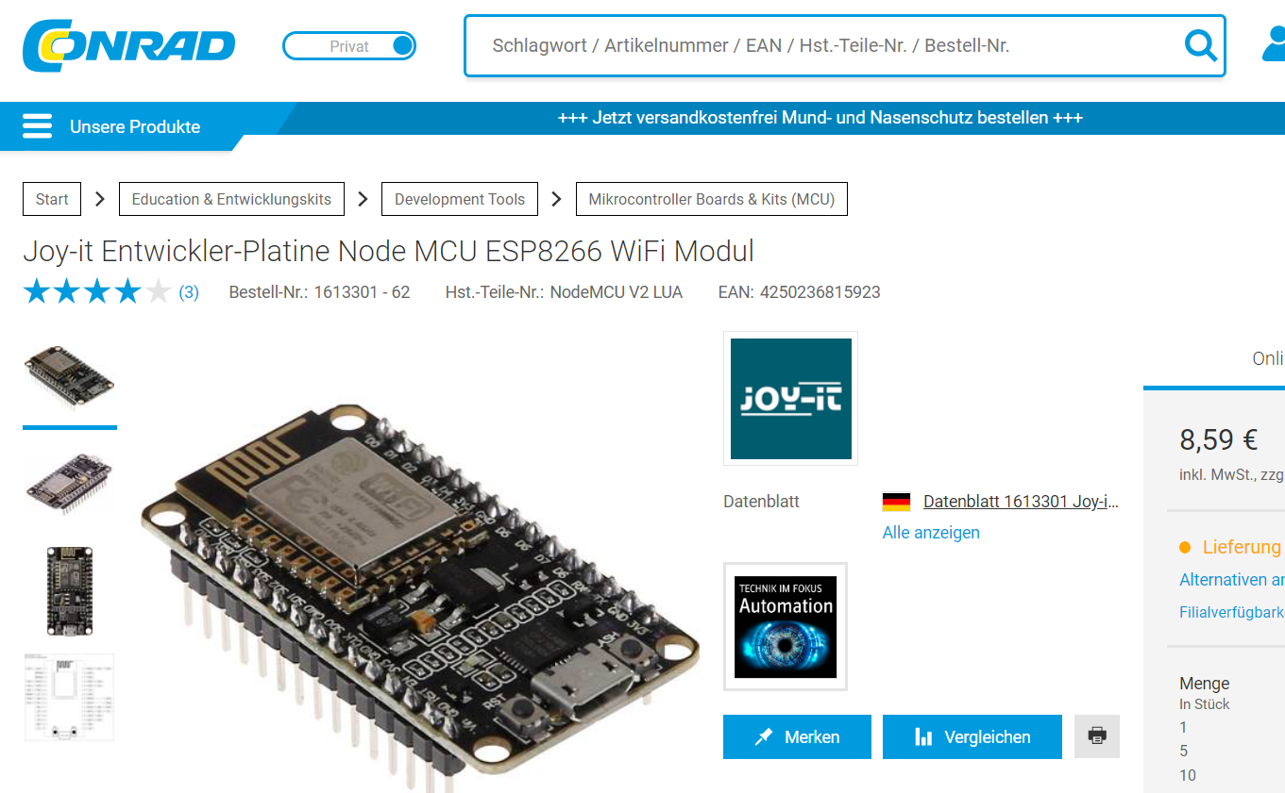

### Power supply

I have used a 9V battery - Here you might consider a different solution so you don't have to change the battery.

A toggle switch to disconnect battery power is also necessary.

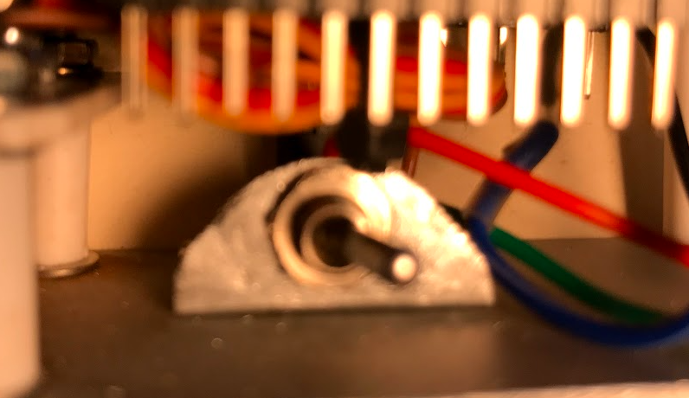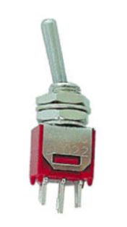

### Camera

Polaroid Cube+ - wifi.

Unfortunately, it does not appear to be available anymore

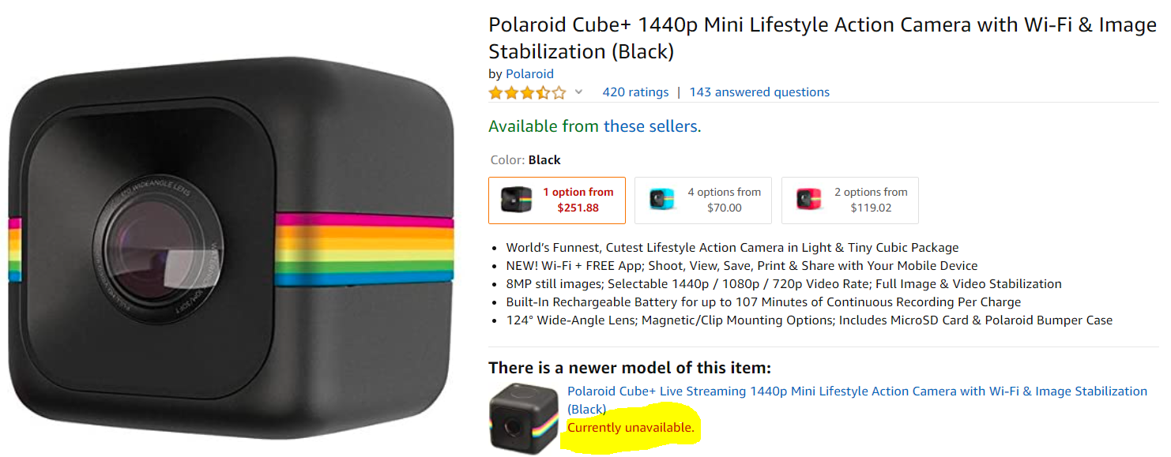

### Connect Node CMU with servo and battery

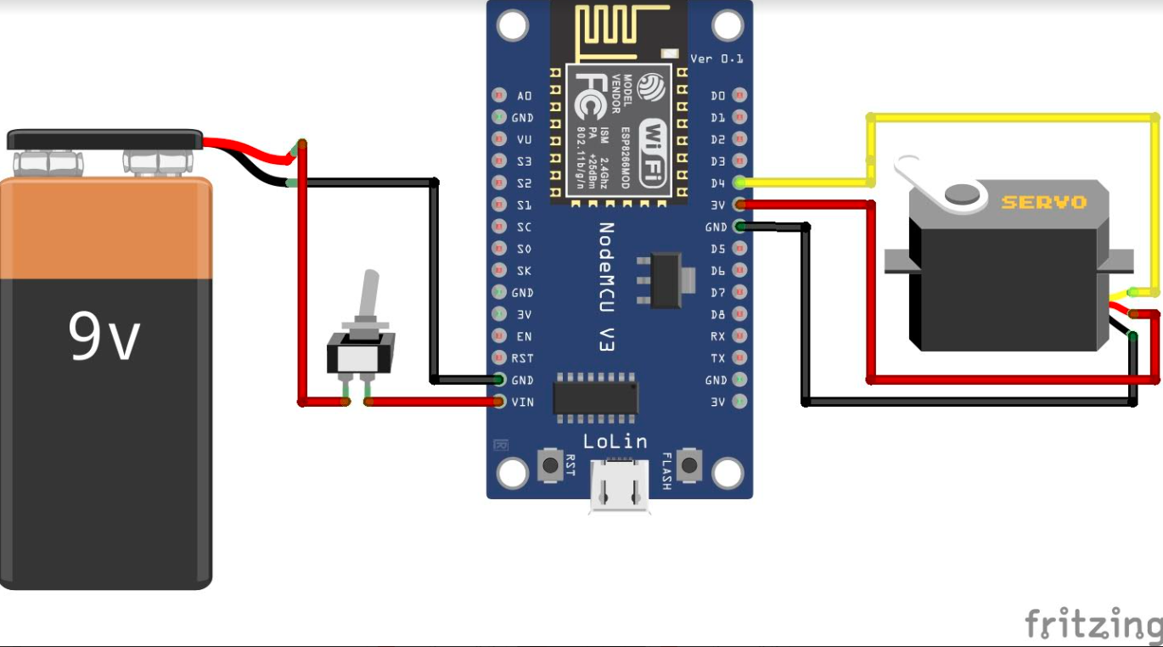

The servo with its three wires is connected in this way:

* Yellow – signal – D4
* Red – 3v
* Black – Ground

The battery is connected to GND and VIN

## BLYNK – app

Here there are two options:

* Import a copy of my Blynk app
* Make your own Blynk-app from scratch

These two options are described in the next two chapters.

### Import a copy of my Blynk app.

Follow the guide below step 1 to 5 to import a full functional copy of my app.

When you have imported my Blynk app – you can make all the changes to it that you want.

| **Step No** | **Description** | **Clip** |
| --- | --- | --- |
| 1 | Install Blynk – app on mobile | Install the App – it is free. |
| 2 | Create an account |  |
| 3 | Import project | Press the QR-Code – button – and scan this code |
| 4 | Check the project.  The project ‘Kamerawaggon – basic’ should now have been imported.  This is the basic project with functionality to operate the servo.  You kann change it – add extra texts – buttons and pictures. To do that you must buy more’ Energy’ – I have bought for 59 dk – it is 7-8 Euro.  You can start with this basic app – and see how it works. |  |
| 5 | Get the Blynk Token | To get the Blynk-token – press this button      Now you can see your Token – it is NOT the same as shown on the picture above.  Presse the E-mail-button – and your token will be email’ed to you. |

### Make your own Blynk-app from scratch

Follow the guide below if you want to make your own Blynk app – and not a copy of my app. See previous chapter.

There are many videos on YouTube describing how to work with Blynk.

Take a look at this video: <https://www.youtube.com/watch?v=EYrEjC3QEew&t=8s>

Install the Blynk app on your Mobile or iPad and follow the instructions in the video above.

Make sure to get the authorization code – you shall use it later.

Below a description of the Blynk app to control the Servo:

|  |  |
| --- | --- |
|  | This is the finished application.  There are 5 buttons with arrows and 2 horizontal sliders.  The other elements are just texts and pictures - you can compose them as you like. |
|  | This is Design view.  Each of the sliders and the angle-buttons have a virtual pin.   * V0 – select angle slider * V1 – speed slider * V2 – 0 degree * V3 – 45 degree * V4 – 90 degree * V5 – 135 degree * V6 – 180 degree |
|  | Detail for: The Select angle slider.  The values are 0 to 180 |
|  | Detail for: The select speed slider  NB: the values goes from 20 to 0  The speed is implemented as an delay in milliseconds between each change of degree.  Example – go from 45 to 90 degree.  We loop from 45 to 90 – that is 45 steps. In each step we have a delay – if the value of the is small – for example 5 – then the speed is fast.  If the delay is high – for example 18 – then the speed is slow |
|  |  |
|  | Detail for: This is button 0 degree – V2.  The other 4 buttons are identical – of course another pin (v3 – v4 – v5 – v6) and another label |

## Coding the Node MCU – ESP8266

Coding of the Node MCU is done in the Arduino environment. First you must configure the Arduino IDE – and the compile the code and send it to the ESp8266.

If you are new in Arduino coding you might want to have a look on this video:

<https://www.youtube.com/watch?v=p06NNRq5NTU&t=331s>

Follow the guide below to code the Node MCU – step 1 to 14.

| **Step No** | **Description** | **Clip** |
| --- | --- | --- |
| 1 | Install Arduino  <https://www.arduino.cc/en/Main/Software> | Install the program    I have installed this program also |
| 2 | Start Arduino IDE form the desktop Icon |  |
| 3 | Connect the ESP8266 to the PC with USB-cable |  |
| 4 | Check com-port  Open device manger – and check the com-port number. In this Example is et COM3 | Now choose this port in Arduino: |
| 5 | Open Arduino IDE |  |
| 6 | Install ESP8266 – board  Choose File -> Properties – | Copy the URL for the line below to the “Additional boards Manager URL” |
|  | <http://arduino.esp8266.com/stable/package_esp8266com_index.json> | |
| 7 |  | In the Board manager- search for esp8266 – now you should see esp8266 – as below      Now – hit the Install button |
| 8 | Choose the NodeMCU 1.0 board – as shown below | |
| 9 | Add extra Libraries  Go to this menu    Now you must add 3 Library’s – choose the last version – and install them  The 3 library’s is listed below: | |
| Find **Blynk** library – and install it | |
| Find **WiFimanager** library – and install it: | |
| Find **DoubleResetDetector** library– and install it | |
| 10 | Remove existing code – and paste in the code | When you start Arduino – there are some line with codes – remove these lines    Now copy and paste in the code-lines rom GitHub. (see row below)  Save the projects    Choose a destination and name for the project |
|  |  | |
| 11 | Copy in the Blynk-Token | In the Blynk installation – step 3 – you emailed the Blynk token. Now find this token and paste it into the code:  That is – replace the yellow-marked text in the code above with your Blynk token.  When you have done it save the project. |
| 12 | Compile the project | Press the Check/compile button    If everything is OK- in the bottom of the screen you will now see this message:    This is Danish – in English it must be Finish compiling..  If there are errors they will belistet and you must correct them. |
| 13 | Send the code to the ESP8266 | If everything is OK – you will see this message in the bottom of the screen |
| 14 | Test – test – test    If there problems connecting the Blynk app to the ESP8266 then take a look at the rest of this chapter. | |

Follow this procedure to connect the Camera Train to your wifi-network – if it not connected automatically:

1 – Find your Blynk token – from mail or in the Blynk app. Copy this token to the clipboard

2 – Turn on the camera-train with the switch button.

3 – On your Mobile/Ipad or PC – find the hotspot ‘ConnectCameraTrain – and choose this hotspot. See Examples below

|  |  |
| --- | --- |
|  | Choose the hotspot ConnectCamaraTrain |
|  | Choose the first button – ‘Configure WiFi |
|  | Choose your WiFI network and type in the password.  The next field is for the Blynk Token (see previous chapter).  Paste in this token here.  Click Save. |
|  | If everything is Ok – you should now see this massage (picture to the left)  And there must be a blue-light on the ESP8266 – as shown below. |